**Washing Machine:**

**Project TimeLine: 14 – 23 Nov 2021**

Simple description:

* A mobile game that’s about washing dirty objects.
* The client wants different types of ads, which is controlled by a firebase variable.

Gameplay description:

* The game has levels; each level has a dirty object that needs to be cleaned.
* The 3D object is rotating around its center all the time.
* A Hosepipe is working all the time.
* The player uses the touch screen to select a point on the object which he wishes the hosepipe to be directed towards to clean.
* When the player fully cleans the object, the level ends and a celebration screen shows.
* The player can skip the level by watching an add.

Tasks:

* Execution tasks:
  + Execute the Unity ads buttons to show ads when the buttons are pressed.
    - Resolved!
    - Test wither the system is recording the impressions.

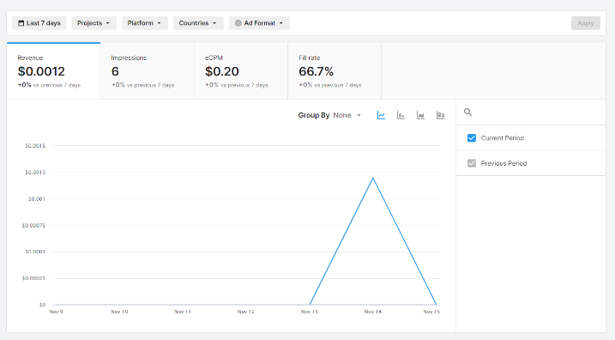

* + Admob might need a google developer account which I don’t have.
    - Resolved! you can use a dummy id.
    - Firebase doesn’t work on build.
  + Firebase to control:
    - Which type of ads is played variable.
  + The game itself:
    - Prototype.
    - Menus:
      * Loading Level Scene.
      * End Game Scene.
        + One Button: Exits the game.
        + Second: Plays again.
      * Level.
        + Level manager Script:

Stores levels and objects associated with them.

Loads which level this is.

Shows an ad when level is done. (make temp end game condition)

On level done:

Loads Next level.

Loads End game scene (if last level).

Make a local save/load system.

* + - Background:
      * VFX doesn’t work on build.
      * Improve the background.
    - Cleaning Mechanism:
      * Improve water hoes model.
      * Water VFX.
      * Create the cleaning mechanism.
      * Create UI to monitor the cleaning.
    - Improve menus:
      * Add backgrounds to loading/end screens.
      * Improve buttons sprites.
      * Improve Loading sprites.
    - Put Audio and VFX:
      * Audio of cleaning that interacts with the cleaning.
        + Water.
        + Score:

Audio.

Particles.

* + - * Improve the background.
      * Improve Graphics.
      * Music.
      * Put New real objects in the level.
    - Ad mob ids setup.
  + Additional Improvements:
    - Water can be limited.

-